**Scenario -1**

**Creating EC2 instance in AWS using Ansible which is available in local on-premise server**

Boto , python and ansible installation on Linux

Installing Ansible,python,boto on ubuntu 20.4

**Update Repository by including the official project’s PPA**

sudo apt-get update

sudo apt-add-repository -y ppa:ansible/ansible

**Refresh the package**

sudo apt-get update

**install ansible**

sudo dpkg –configure -a

sudo apt-get install -y ansible

**Installing package manager for Python on ubuntu 20.4**

sudo apt install python3-pip -y

**Installing Boto framework -AWS SDK**

Ansible will access AWS resources using boto SDK

sudo apt-get install python3-boto -y

sudo pip install boto boto3 [Some data center support boto and some boto 3]

**Check ansible/boto installation**

ansible –version

pip list boto | grep boto

pip show boto3Fall-

AWS account with privilege to Launch EC-2 Instance

<https://www.middlewareinventory.com/blog/ansible-aws-ec2/>

**Installation On Mac**

**Installing Python Package Manager**

Python Package Manager (PyPM) is a Python utility intended to simplify the tasks of locating, installing, upgrading and removing Python packages

* Check your Python version to make sure Python3 is installed

python3 –version

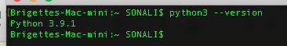

* Down load pip by running the following command

curl <https://bootstrap.pypa.io/get-pip.py> -o get-pip.py



* Installed the download package by running the following command

python3 get-pip.py



* Verify the successful installation pf PIP package

pip –version



**Installing Ansible**

* Use pip to install Ansible

sudo pip install ansible

* Down load pip by running the following command

ansible --version

**Installing Boto, Boto3**

**What is Boto?**

Boto is an Amazon AWS SDK for [python](https://crunchify.com/ansible-how-to-grep-ps-few-and-kill-process-running-on-remote-host/). Ansible internally uses Boto to connect to Amazon EC2 instances and hence you need Boto library in order to run [Ansible](https://crunchify.com/what-is-ansible-pre_tasks-how-to-update-os-install-python-and-install-jre-on-remote-host/) on your laptop/desktop.

Some data center support boto and some boto 3

* Use the following command to install boto3

pip install boto3 --user

* Use the following command to install boto

pip install boto --user

* Check the version installed both for boto and boto3

pip list boto | grep boto

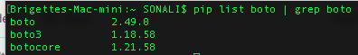

**Installing AWS CLI**

The AWS Command Line Interface (AWS CLI) is an open source tool that enables you to interact with AWS services using commands in your command-line shell.

* For the latest version of the ASW CLI, use the following command block

curl "https://awscli.amazonaws.com/AWSCLIV2.pkg" -o "AWSCLIV2.pkg"

sudo installer -pkg AWSCLIV2.pkg -target /

* To check whether aws cli installed correctly

aws –version



For details of install/uninstall/update please follow the following link from AWS

<https://docs.aws.amazon.com/cli/latest/userguide/install-cliv2-mac.html#cliv2-mac-install-gui>

**How connect to AWS EC2 Instance by using command line argument from AWS CLI on Linux/Mac?**

* Go to: https://console.aws.amazon.com/iam/home?#/users
* Create user

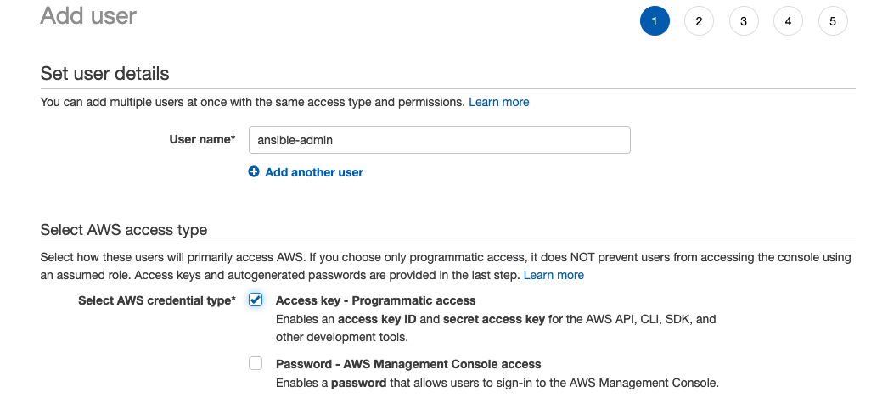

* Set permission by clicking on Attach existing policies directly

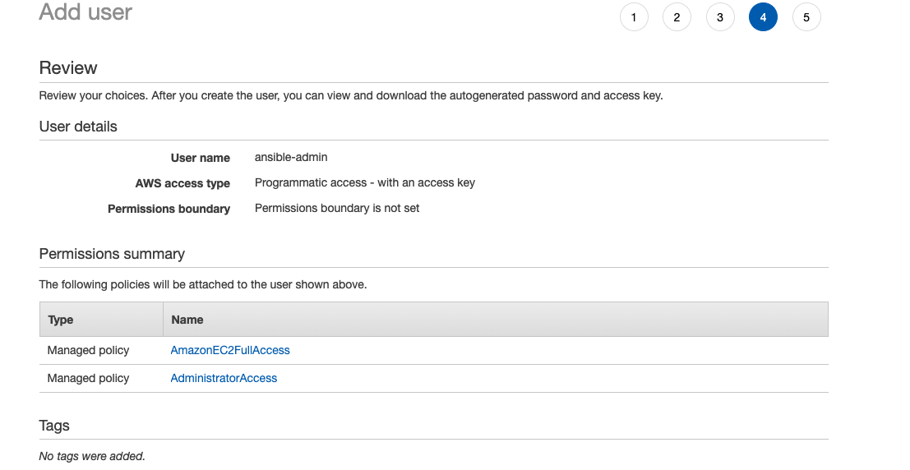

* Download Amazon AWS Access Key ID, Secret Access Key

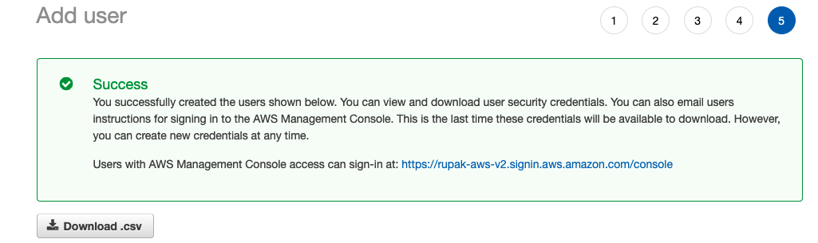

* Make sure One of the EC2 instance is up and running if not create a new EC2 instance



* Set up Amazon AWS credential

There are many ways we can set up Amazon AWS credential

Just type aws configure command. Enter your Amazon Access key ID and Secret access key.

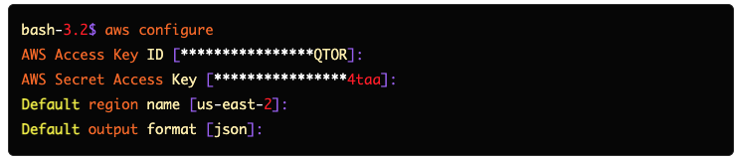

* Run the following command from your command line of mac/linux to get the ec2 instance details

aws ec2 describe-instance

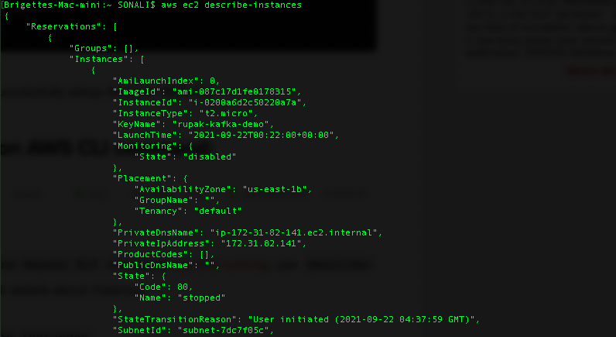

**AWS – Create a new EC2 Using Ansible Playbook**

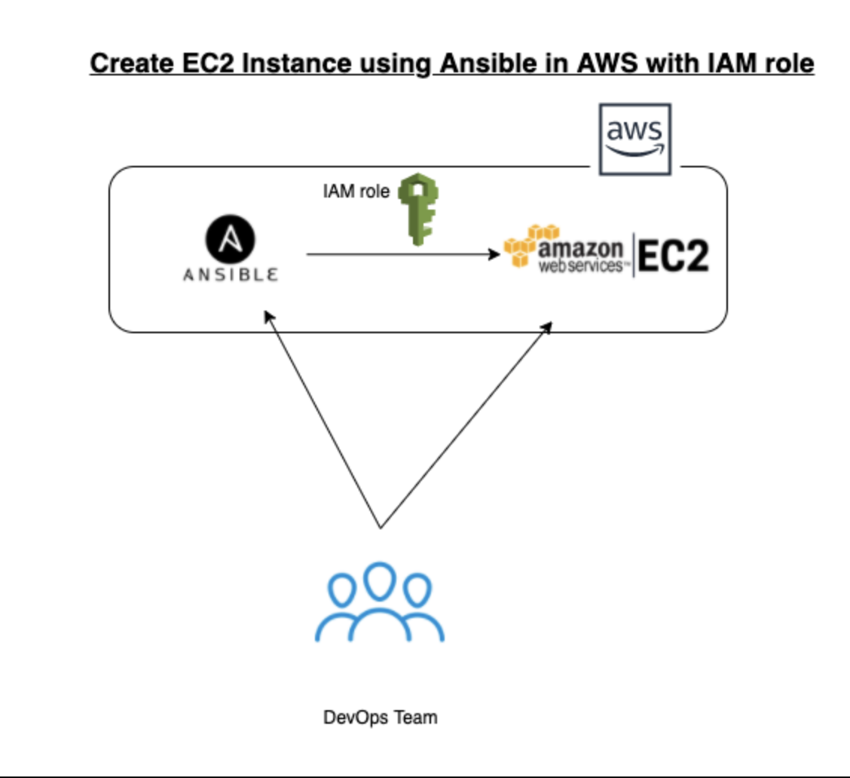

**Step-1 : Create Access Key**

We must create an access key for our ansible on the controller node to be able to access the AWS account. Click on the **username** on your AWS Portal and from the drop down menu select "**My Security Credentials**"

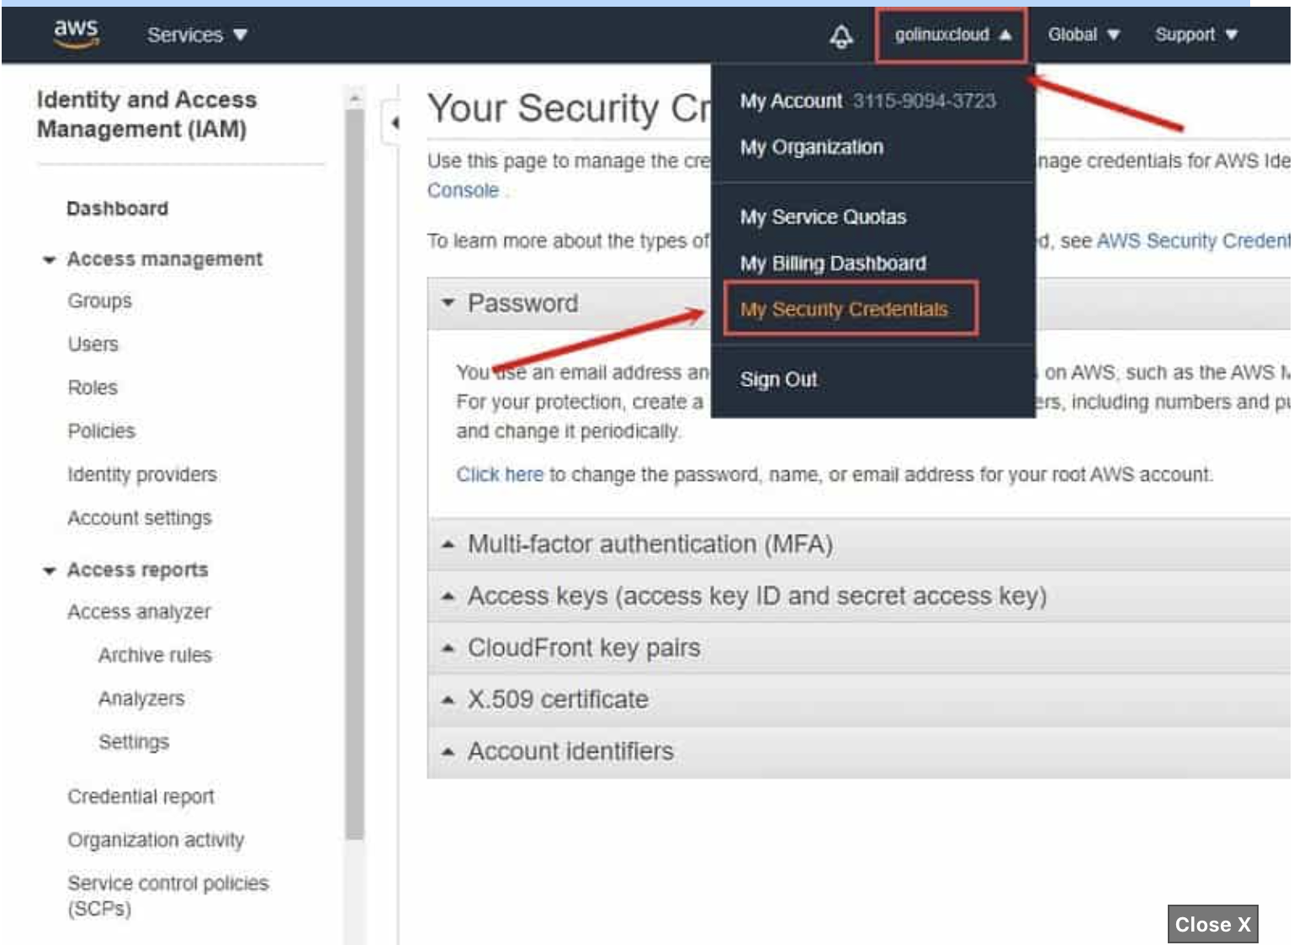

Next click on "**Access keys (access key ID and secret access key)**" to expand the drop down menu and click on "**Create New Access Key**"

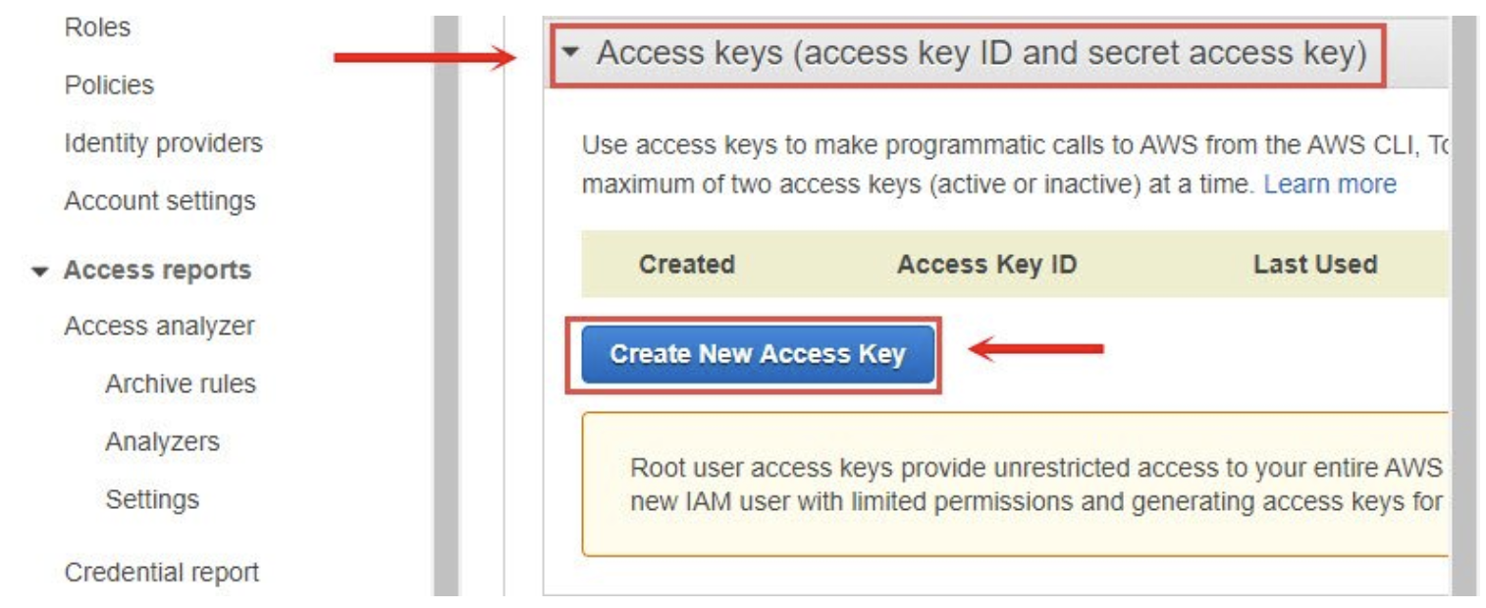

This should create a new access key. It is **IMPORTANT** that you either download the key file or save both Access Key ID and Secret Access Key as you will not be able to retrieve this later as the message says on the console.

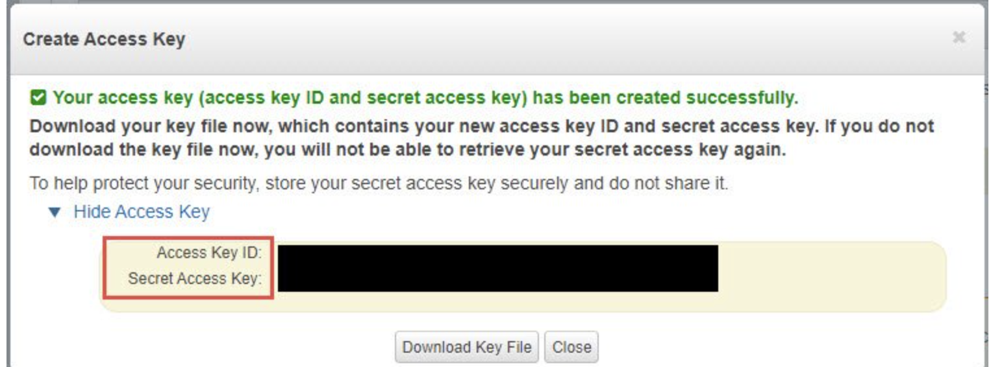

**Step-2 : Store Access Key**

We will use awscli to store our login credentials instead of the playbook for better security which requires awscli tool. We can install awscli using pip3 as instructed above. Make sure aws cli is installed .

Now we can store our access key using awscli. Execute **aws configure** from the console as ansible user:

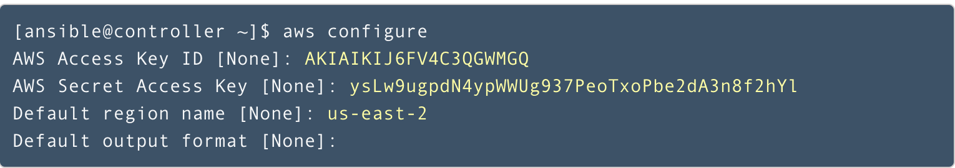

Now you can access your configuration which will be stored in the home folder of ansible user under ~/.aws

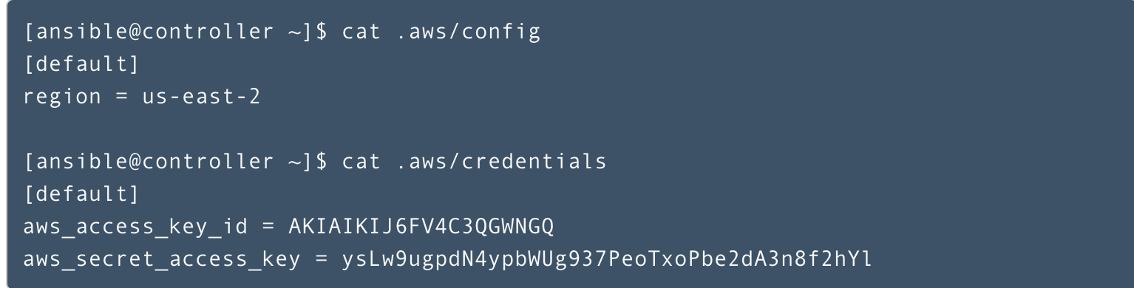

**Step-3 : Create or Edit Ansible host(inventory) file**

The Ansible inventory file defines the hosts and groups of hosts upon which commands , modules and tasks in a playbook operate. By default when you install ansible it can be found (ubuntu Linux) at the path /etc/ansible/hosts .

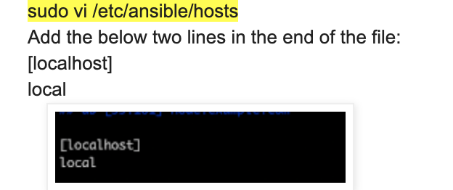

you can open the file and edit it or you can create a inventrory file in any directory you like to create and and the following entry

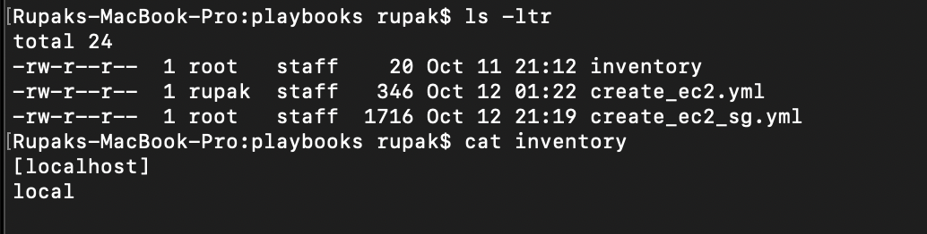

**Step-4 : Create Ansible playbook file to provision a new EC2 instance**

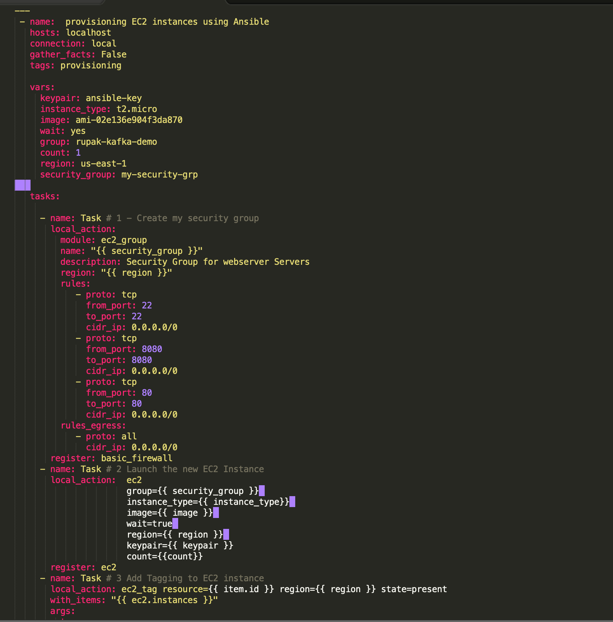



**Step-4 : Execute Ansible playbook command**

Ansible Playbook

sudo ansible-playbook -i inventory create_ec2_sg.yml --key-file "~/.ssh/id_rsa.pub" --connection=local -e "ansible_python_interpreter=/usr/local/bin/python3"

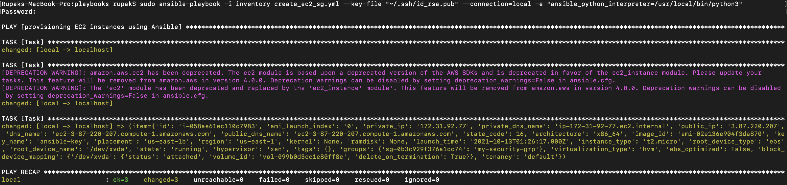

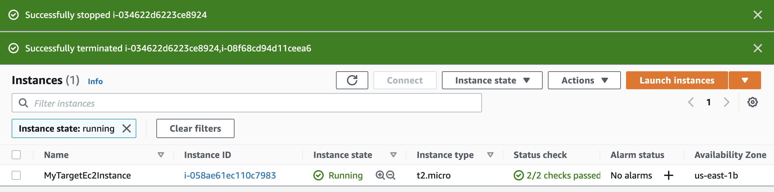

**AWS – Start a stopped EC2 Using Ansible Playbook**

**Step-1 : Create Ansible playbook file to Strat EC2 instance**

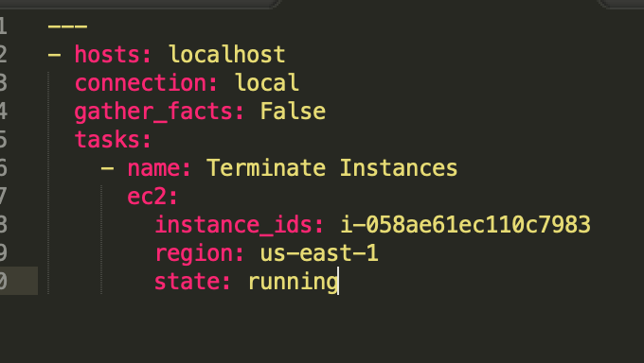

**Step-1 : Run the following ansible play command**

sudo ansible-playbook -i inventory ec2_start.yml --key-file "~/.ssh/id_rsa.pub" connection=local -e "ansible_python_interpreter=/usr/local/bin/python3"

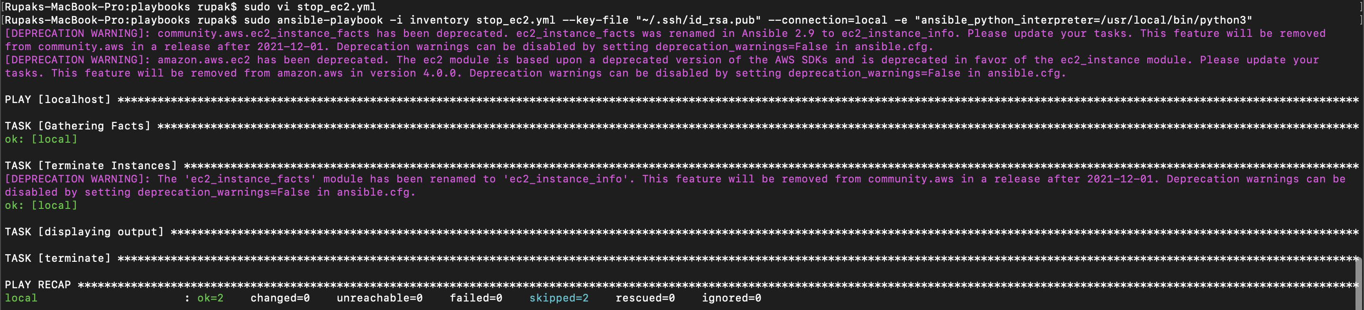

**AWS – Stop a already Started EC2 instance Using Ansible Playbook**

**Step-1 : Create Ansible playbook file to Stop EC2 instance**

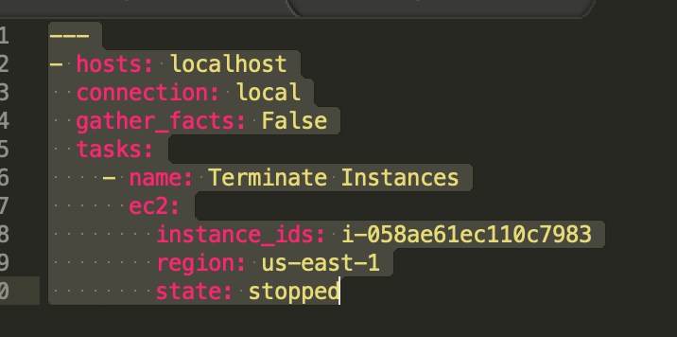

**Step-2 : Run the following ansible play command**

sudo ansible-playbook -i inventory ec2_stop.yml --key-file "~/.ssh/id_rsa.pub" --connection=local -e "ansible_python_interpreter=/usr/local/bin/python3"

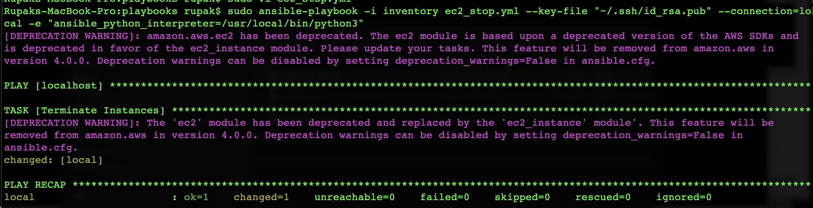

**AWS – Terminate EC2 instance Using Ansible Playbook**

**Step-1 : Create Ansible playbook file to Stop EC2 instance**

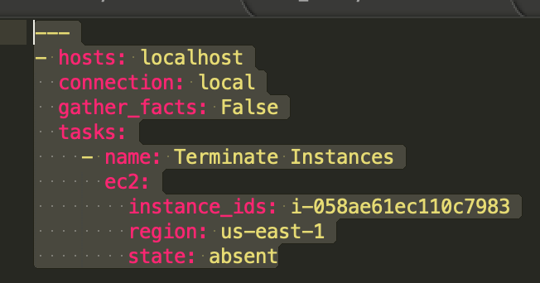

**Step-2 : Run the following ansible play command**

sudo ansible-playbook -i inventory ec2_terminate.yml --key-file "~/.ssh/id_rsa.pub" --connection=local -e "ansible_python_interpreter=/usr/local/bin/python3"

